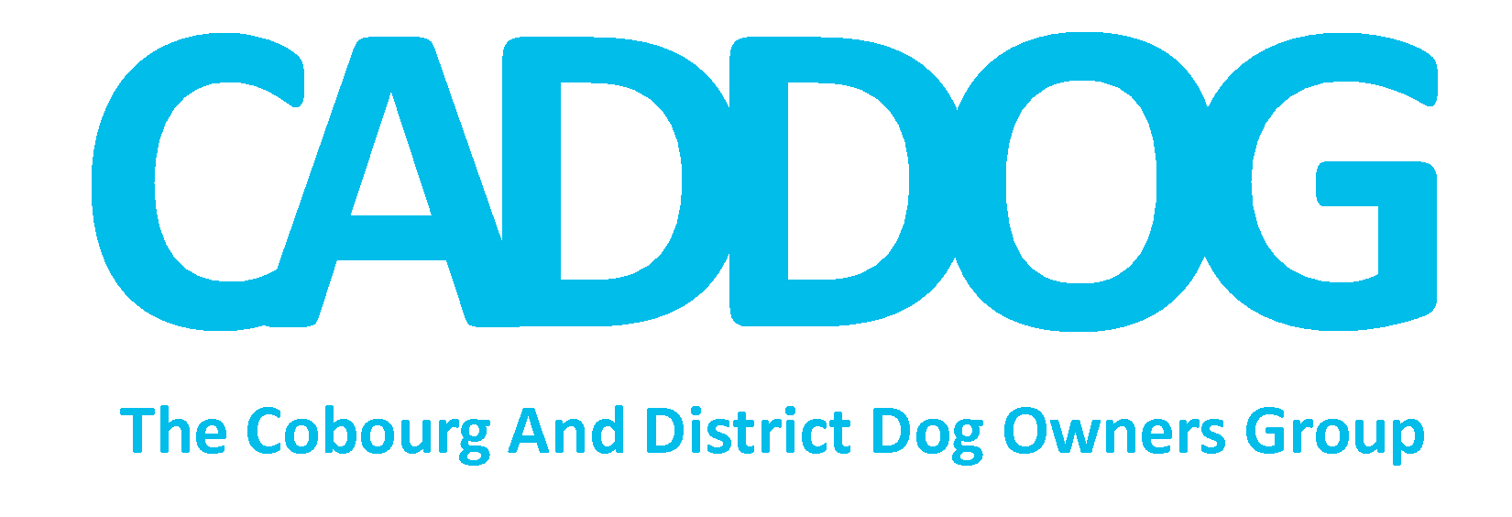
Application for 2017-2018 Membership
Approved Memberships valid for one year

Name: Address: Town: Postal Code: Email: Telephone:
Please print (we will mostly contact members by email so please provide one to keep you up-to-date)

Dog’s Name: Dog’s Name: Dog’s Name:
Breed: Breed: Breed:
Sex: M F Sex: M F Sex: M F

Membership Fee ($20 per household) included: Yes No Additional Donation: $ Received with thanks!
All funds raised will be for the exclusive use of CADDOG and its mandate to support and enhance the off-leash Cobourg Dog Park.

I have read and agree to abide by the CADDOG Member Code of Ethics and by signing, I consent to the CADDOG Privacy Policy (please read, print & check off boxes below, then submit.)

Signature required Date

COMPLETED FORMS WITH PAYMENT can be mailed to the attention of Jan Rosamond at RE/MAX LAKESHORE 1011 Elgin St. Cobourg K9A 5J4 or dropped off to Re/Max Lakeshore in a sealed envelope. Payment can also be completed through Paypal or etransfer to info@caddog.org through our website: www.caddog.org .

Member Code of Ethics
The Cobourg and District Dog Owners Group (CADDOG) is a Town of Cobourg sanctioned association operating as a paid membership organization representing dog owners and supporters of the organization. They serve as an advocacy group on behalf of peoples’ collective needs and the needs of their beloved pets. CADDOG was formed in April of 2014 with a Constitution, By Laws and Policies approved by members. CADDOG is not a registered charity. An Executive Committee of volunteers is elected annually by and from members and is responsible and accountable to membership.

In order to achieve the Purpose, Goals and Objectives of CADDOG, its members agree to the following:

All CADDOG Members in Good Standing will:
- Respect and comply with the By- Laws, Rules, Regulations and Policies established by CADDOG and support the Rules and Requirements of the Town of Cobourg governing the use of designated Off Leash Dog Parks
- Acknowledge that as users of Off Leash Dog Park areas they are subject to the Dog Owners Liability Act
- Provide their dogs with appropriate housing, food and health care.
- Endeavour to advocate and enhance the role of dogs in society as an essential member of its communities where it functions as a companion, guardian, healer, therapist, teacher and above all “man’s best friend”
- Undertake the task of welcoming, educating and encouraging all newcomers to CADDOG while respecting their interests: off leash parks, training, community awareness and education
- Take the initiative to be a responsible and conscientious group ensuring that their actions support the privilege of regulated off leash spaces
- Understand that personal information supplied on Membership Application Forms is protected by the CADDOG Privacy Policy. Such information will be held in the strictest confidence for internal use only by CADDOG Executive.
- Accept their responsibility to observe and monitor dog park activity including behaviour of dog owners and their dogs, evidence of vandalism and/or malfunction of equipment, and safety hazards. Members agree to report violations of responsible behaviour, witnessed incidents and maintenance requirements to appropriate authorities
- Whether serving as Executive Officers, Committee Chairpersons or volunteers at large who participate in CADDOG activities shall do so with honesty, fairness and integrity ever mindful of the practice of being a good example to others.
- Understand that complaints of serious misconduct and/or violation of CADDOG Code of Ethics could result in a membership being revoked in accordance with CADDOG Policy on Membership/Enforcement.
- When voting at General or Special meetings of CADDOG, declare any Conflict of Interest whether it be of the nature of any political connection or significant interest of personal monetary gain by way of ownership in, employment by, or directorship of and holding office in any organization deemed to be in competition with CADDOG or in conflict with CADDOG Goals and Objectives.

